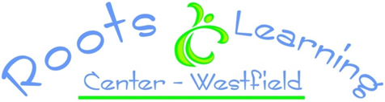

On behalf of the staff at Roots Learning Center, welcome! We are pleased that you have chosen our center to share the early years of your child’s life. What an exciting journey lies ahead! The road will be filled with many joys as you watch your child reach new developmental milestones. There may be times of frustration or uncertainty for you as well; leaving your child in the care of others is often a very difficult decision. Please remember that we are here as partners in raising your child. We will love and encourage them, and keep them safe while you are away. We enjoy having parents visit as often as their schedules permit, so please come and share your child’s world whenever possible.
This handbook has been designed to help you understand the philosophy on which our center is based, to give you insight into the policies and procedures of RLC and to familiarize you with the daily routines of your child’s day while you are away. Its size may seem daunting but it is important that you read this handbook carefully and keep it in a convenient place for future reference. Carefully complete and sign all forms and return them before your child’s first day of care. We thank you for enrolling your child with Roots Learning Center!

Your child’s classroom will be ____________________________________ and your child’s teachers will be _______________________________________________________________.

If you have any questions or concerns you can come to me any time, my door is always open!

Sincerely,
Stephanie Anderson
Director
Roots Learning Center - Westfield
217 Root Road, Westfield, MA 01085
Phone: 413-562-1767
Fax: 413-562-4354
Email: stephanie@rootslearningcenter.com
Website: www.rootslearningcenter.com

I have thoroughly read the Roots Learning Center Parent Handbook and I will keep it for future reference. I will speak to Stephanie or my child’s teachers if I have any questions regarding RLC’s policies and procedures.

Child’s Name:_________________________________________________ DOB:________

Parent Signature:_______________________________________________ Date:_________

Valid for one year from date signed.

